Name

Positions

Institute for Sustainability and Innovation in Structural Engineering (ISISE)
Civil Engineering Department – University of Minho
Campus de Azurem, Av. da Universidade, 4800-058 Guimaraes, Portugal

SCOPUS | ORCID | Research Gate | Google Scholar (optional links to personal pages-delete this text)

 | 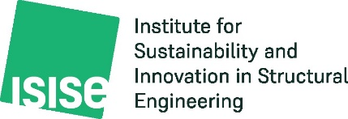 | Other logos- delete this text

